Kowsik Penamakuru, M13955754

Introduction:

For the assignment 1 of the design thinking module, I have chosen working desks from two different locations. One is the working desk at my home and the other is a desk at my new job at Faculty Enrichment Center at UC. I have drawn the below sketches of the work desks after spending 30 minutes at each location.

Familiar location: Work desk at home

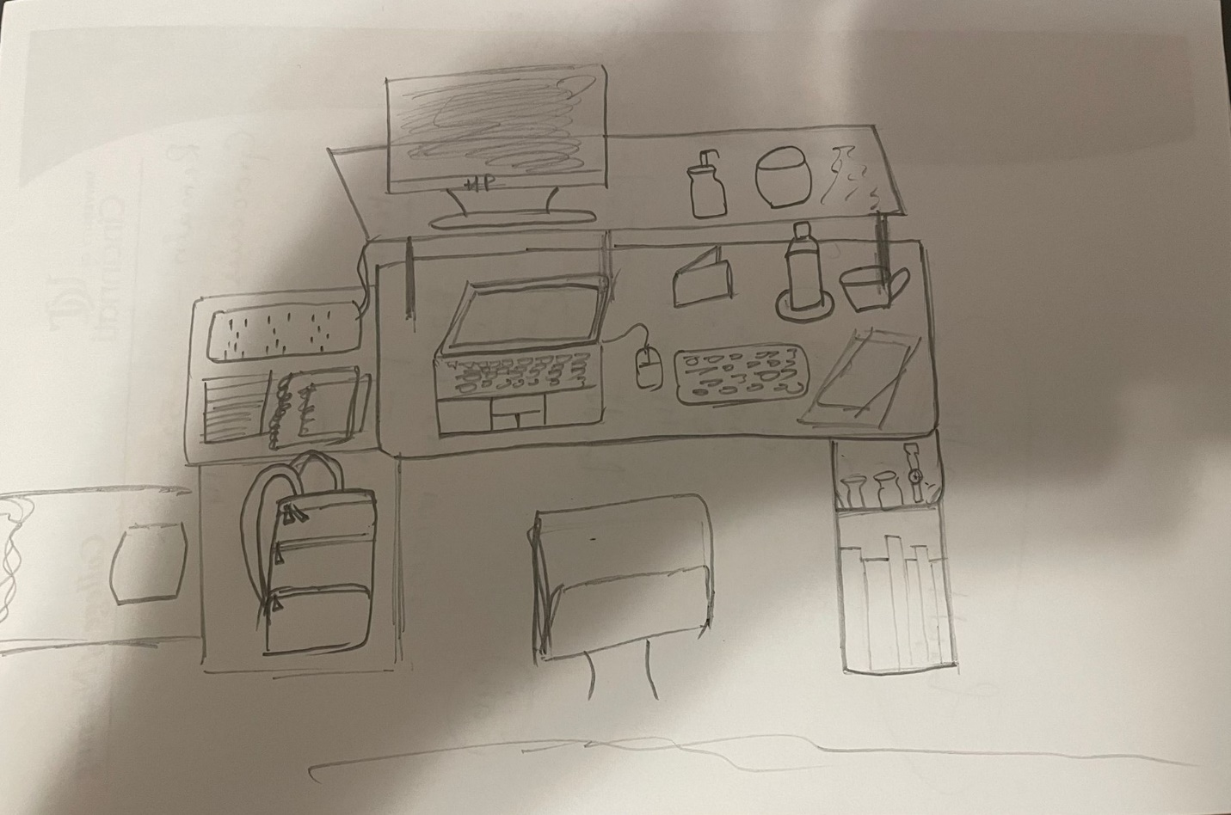

Make note of the structural elements you’ve chosen to represent the scene.  Why are these noteworthy?

As the locations I have chosen are from work, I found the technology to be the noteworthy structural element. My desk is equipped with a Lenovo laptop that has an i5 processor, a 24-inch extended Monitor from HP, a wireless keyboard and a mouse. I also had some personal items such as my wallet, books, water bottle and a sanitizer when I spent my time observing the desk and the place around. I have decided the technology to be the noteworthy element as it occupied the major part of the desk and is the main reason for using the desk.

What elements are missing?

A reading light was missing along with the option to adjust the height for both the desk and the chair. The chair was also missing the hand rests on both the sides. A pair of headphones would have been better. Thought I couldn’t represent through the sketch, my desk setup had bad lighting and it wasnt ergonomically co-operating

Unfamiliar location – Work desk at my new job at Faculty Enrichment Center at UC

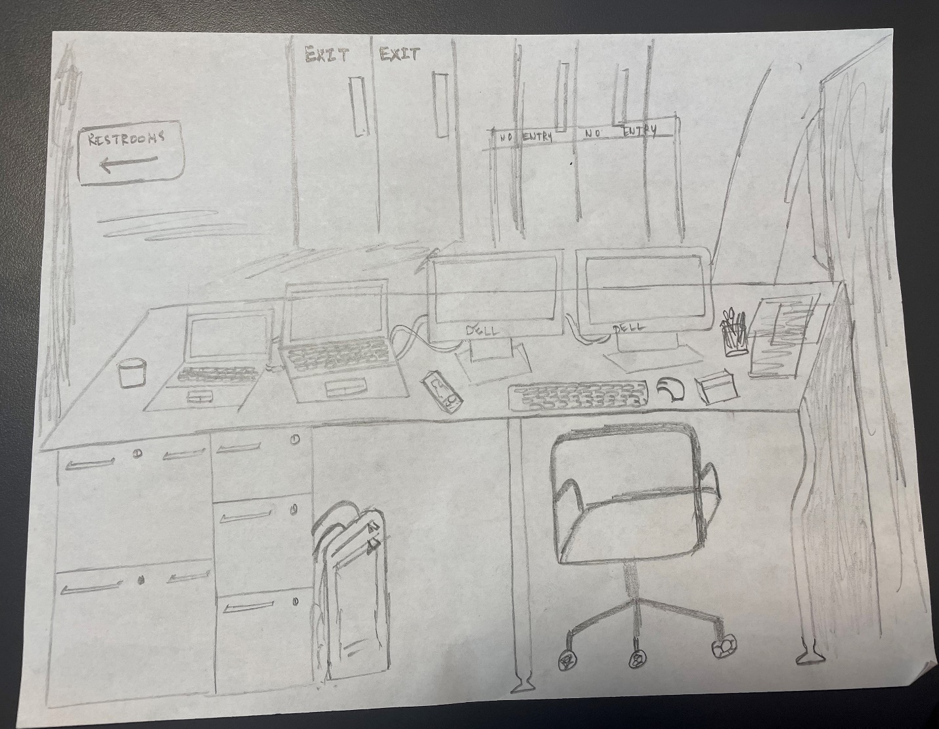

Make note of the structural elements you’ve chosen to represent the scene.  Why are these noteworthy?

The noteworthy structural elements from my workplace also turned out to be the technological elements. I had a couple of laptops – one Dell & one Lenovo, 2 24-inch extended monitors, a wireless keyboard and a mouse, a pen stand, drawers to organize files and stationary items etc., I found these to be noteworthy because they take up major space on the desk and they are the main purpose the desk was setup.

What elements are missing?

The place was not quiet as a lot of people were entering and leaving throughout the time I was working. There wasn’t any extension cord to plug in and charge my phone. Privacy was also missing at this location.

What was the difference in the two scenes?

The major difference was the setup at my workplace was more professional than the one I had at home. The desk and technology is costlier than the desk and technology at home. The arrangement at office was more sophisticated. Quietness and privacy were abundant at the home desk setup where the same were badly missing at my workplace. Technology is more advanced at my workplace and IT service was easily available and at free of cost.

How did you see or perceive the familiar location with the unfamiliar location?

I was more comfortable at the familiar location. I think I also felt more confident at the familiar location. Probably because there was no watching over me whereas at the familiar location, I felt like I was being observed and hence I couldn’t be very flexible and free while using the setup at my workplace.

Were you at an advantage or disadvantage with the familiar location?

I was able concentrate more at the familiar location because I had more quietness and privacy. However, I also had a technology disadvantage. The laptop I was using was old and it slows down if I am using a lot of applications at once.

Knowing something about yourself, how does this influence what you see, perceive and understand?

These two locations have influenced my perception in such a way that 2 similar things can still be very different and the subtle differences between them does make a lot of difference. I also understand that nothing can be perfectly setup and provided and few compromises are required to be made to achieve the purpose.